Date: 25 /03/2025
Ref. No.: ICEM/Feb2025

One Page Report on “Celebration of Suit and Gown Day”

Date: 11th February 2025
Venue: Avirat
Time: 3:00 PM

Brief Report:

Indira College of Engineering and Management (ICEM), Pune, will celebrate Suit and Gown Day on 11th February 2025 to promote professionalism, elegance, and confidence. The event will feature a Ramp Walk Competition where participants—students, faculty, and staff—will showcase their best formal attire. A panel of judges will evaluate the participants on style, presentation, and confidence, with audience voting adding to the fun and excitement.
The event encourages participants to dress in stylish suits and gowns, emphasizing the importance of professional dressing for career success. It aims to boost participants' confidence, creativity, and public speaking skills while enhancing college spirit through friendly competition.
With a large turnout expected, the Ramp Walk Competition will offer an exciting platform for students to express their style. Prizes will be awarded to top participants, making the event both fun and competitive.
Suit and Gown Day will be a memorable occasion, fostering confidence, creativity, and professionalism among participants and contributing to a vibrant college community.

Few Glimpses from the Event:

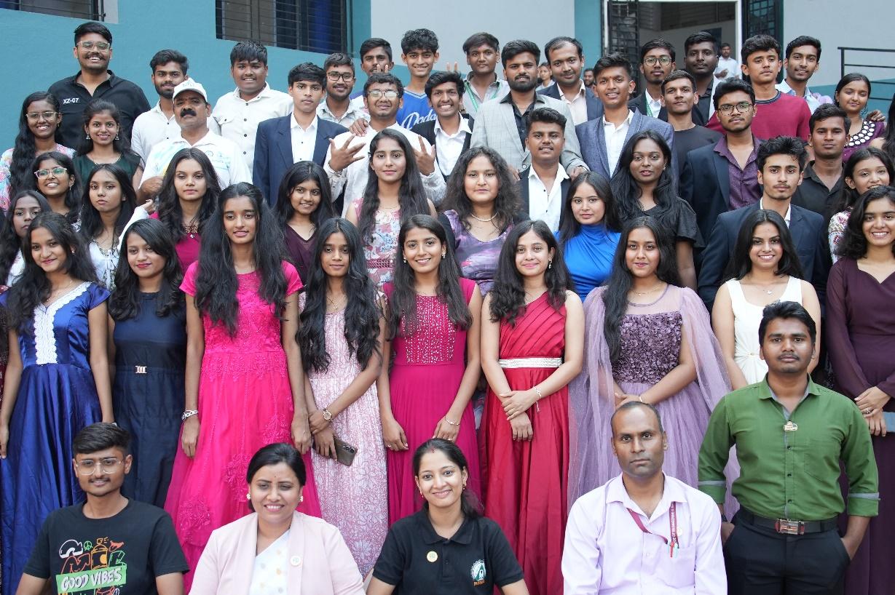

Preapred by: Submitted To:
Prof. Reshma Kohad Dr. Soumitra Das
Cultural Coordinator I/C Principal

